**ITCS 6112 Fall 2018**

**Emotion Detection System**

**Software Requirement Specification**

**Pallav Jhaveri, Gunjan Kushwah, Rithesh Shetty,**

**Pranoti Desai**

**Version: 1.0 Date: 11/26/2018**

**Table of Contents**

|  |  |
| --- | --- |
|  |  |
| **1. Introduction** | **3** |
|  |  |
| *1.1 Purpose* | *3* |
|  |  |
| *1.2 Scope* | *3* |
|  |  |
| *1.3 Glossary* | *3* |
|  |  |
| *1.4 References* | *3* |
|  |  |
| *1.5 Overview* | *4* |
|  |  |
| **2. The Overall Description** | **4** |
|  |  |
| *2.1 Product Perspective* | *4* |
| 2.1.1 System Interfaces | 5 |
| 2.1.2 User Interfaces | 5 |
| 2.1.3 Hardware Interfaces | 5 |
| 2.1.4 Software Interfaces | 5 |
|  |  |
| *2.2 Product Functions* | *6* |
|  |  |
| *2.3 User Characteristics* | *7* |
|  |  |
| *2.4 Constraints* | *7* |
|  |  |
| *2.5 Apportioning of Requirements.* | *7* |
|  |  |
| **3. Specific Requirements** | **8** |
|  |  |
| *3.1 Functional Requirements* | *8* |
| 3.1.1 Detailed Use Case Elaboration | 8 |
| 3.1.2 Domain Class Diagrams | 10 |
| 3.1.3 Sequence Diagram | 11 |
|  |  |
| *3.2 Performance Requirements* | *12* |
|  |  |
| *3.3 Design Constraints* | *12* |
| 3.3.1 Usage of the Application | 12 |
| 3.3.3 Response Time | 12 |
| 3.3.3 System Dependability | 12 |
|  |  |
| *3.5 Non Functional System Requirements* | *12* |
| 3.5.1 Reliability | 12 |
| 3.5.2 Availability | 12 |
| 3.5.4 Maintainability | 13 |
| 3.5.5 Portability |  |
|  |  |
| **4. Technical Documentation** | **13** |
| *4.1 Programming Languages Used* | *13* |
| *4.2 Tools and Environment* | *13* |
| **5. Supporting Information** |  |
| **6.** **Appendix A: Version Control** | **14** |

**1. Introduction**

**1.1 Purpose**

This document is to provide a detailed description of the Emotion Detection System from Text. The document will illustrate the functionality of the system, system users, required applications to support the system and the services provided by the system.

The purpose of the document is to facilitate an understanding of the services that the system will provide, for both stakeholders and developers.

**1.2 Scope**

The emotion detection system will provide the user with the emotion expressed in the text by parsing the text provided. More specifically, the system will detect the emotions into anger, disgust, fear, guilt, joy, sadness and shame from the text provided by user and return a label assigned to the emotion.

The system will have a text box in which the user can enter the text and will hit the submit button. The user will be returned with detected emotion after the text is parsed in the backend. The emotion recognition system will parse the sentence and pick the keywords and recognize the emotion that matches those keywords. Average emotions recognized for each and every sentence will form a report that will help users with feedback on the text.

**1.3 Glossary**

|  |  |
| --- | --- |
| **TERM** | **DEFINITION** |
| Software Requirements  Specification | A document that completely describes all of the functions of a proposed system and the constraints under which it must operate. For example, this document. |
| Stakeholder | Any person with an interest in the project who is not a developer. |
| Collaborative Filtering | A technique used to provide personalized recommendations, wherein user preferences are compared with similar preferences of other us |
| Active User | A user who is accessing and using the system at a current moment in time, in order to receive music recommendations. |

**1.4 References**

IEEE. *IEEE Std 830-1998 IEEE Recommended Practice for Software Requirements*

*Specifications.* IEEE Computer Society, 1998.

**1.5 Overview**

Overall Description section elicits and explains the general functionality that the system will provide. It will provide how and what services the system will provide in an understandable language. It will be easy for the stakeholders of the project as they might not be having technical background.

The following section, Requirements Specification, is a technical description of the product and its constraints. It is designed to assist developers in their work, but should be intelligible for all readers of the document.

Both sections will serve the same purpose; that is, explicitly describing the system’s functionality, users, and constraints. However, each section has an intended audience, and therefore the two sections may use different types of description.

The fourth section will provide the technical details of the document and what all environments and languages have been used.

The fifth section is the conclusion and the result following the work distribution.

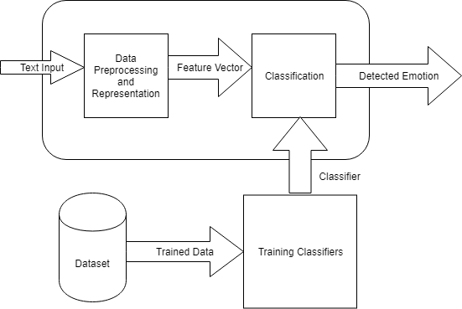

**2. The Overall Description**

This section will provide a high-level, natural-language description of the services that the software will provide. It takes a holistic view and can serve as a context for further reading into the technical specifications (section 3).

**2.1 Product Perspective**

The emotion detection system will help users to detect emotions based on the text they provide. Users will require accessing the web page to interact with the system and provide the text. They would also require internet connection for the same. This is helpful for domains of human computer interaction, and natural language processing.

There will be a single actor, the user who will provide the text input and will get the emotion with respect to the text. Using internet, the user will interact with the single system. The user will input the text which will be parsed by the system and return the emotion for the text.

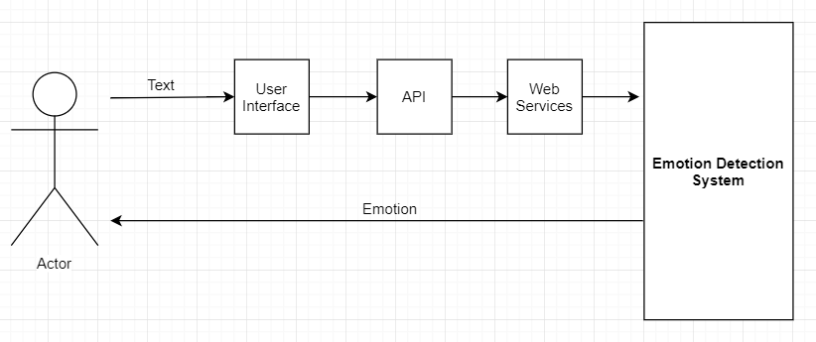

**Figure 2.1.1: System Overview**

**2.1.1 System Interfaces**

The system is a hybrid trained model in python which will parse the input text and predict the emotion present into it. There are seven classes of emotions anger, fear, disgust, shame, joy, sadness and guilt. The system will detect an emotion out of these. The user can enter the text on which the emotion is to be detected by the UI. RESTful web services are implemented in python to communicate with the backend system. The system will be implemented as a web application, and it will therefore interact with different user browsers and operating systems.

**2.1.2 User Interfaces**

The system User Interface is a single page designed using HTML5, CSS, JavaScript and Bootstrap. The user is provided with a text box to feed in the input text. There is no need to login or signup for the user to use the application. After providing the input text, the system will perform the necessary operations in the background, so that the user is not made aware of specific system operations. After the emotion is detected, the user is displayed with the result in the form of an image corresponding to the emotion.

**2.1.3 Hardware Interfaces**

The software will run on any internet connected device, independent of hardware.

**2.1.4 Software Interfaces**

The software will run on an internet connected device, independent of operating system or browser. We will assume that the active user’s device has some minimum functionality of processing speed and connectivity speed.

**2.2 Product Functions**

**Use Case Diagram:**

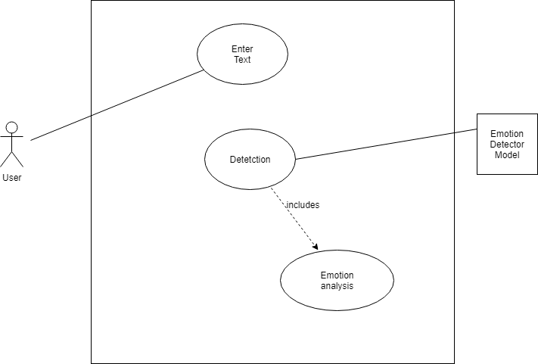

**Use Case: Enter Text**

**Brief Description:**

The user will input the text, paragraph to the textbox.

**Step-by-Step Description:**

1. The user will enter the text in the text box.
2. The system will pass the text to the web services.

**Use Case: Error Detected**

**Brief Description:**

**Step-by-Step Description:**

1. The user selects log out.

2. The system ends the particular user session.

3. The system displays the homepage.

**Use Case: Detect Emotion**

**Brief Description:**

The trained model will take in the text as input and provide the appropriate emotion.

**Step-by-Step Description:**

1. The trained model will receive the text as input.

2. The analysis will be applied to the text based on the dataset.

3. The emotion detected will be sent through the API.

**2.3 User Characteristics**

The target users of this application can be bloggers and twitter analysts who can check the emotions of any blog, tweet or a comment. Any Ecommerce firm can also use this emotion detection system to determine the product review. This system is not restricted to a specific group of users but can be used by any user who wants to determine a emotion present in a particular text. The emotion detector can be used to find the happiness index of the people (recently government is working on that). It can also be used to check the tone of person, writing email, blogs or even tweets.

**2.4 Constraints**

A primary concern is the accuracy of the emotions detected. Since this is still in the state of the art phase, the accuracy obtained is 54. We have used the dataset provided by Microsoft. As per there system which detects emotion into five classes has obtained an accuracy of 60%.

Availability is one of the important factors in determining good software. The system will be easily accessible that is it should have a simple and easy operating constraints so that the user will be able to use it with ease. The system should be easy to use since the user definitely does not want to spend time on learning how to use the system.

The system can determine the emotion provided the user feeds in a valid input. The internet connection of users will be a constraint for accessibility of the system, since the application will require internet to function.

The ability of the system to run on any operating system is important constraint. The potential software should be platform independent.

**2.5 Apportioning of Requirements.**

Our final system, at the current moment in time, will not include have Login/Signup feature. This system feature is put on hold by our team due to time constraints and expects to include the above mentioned feature in the next release of the software in the future.

**3. Specific Requirements**

This section provides a detailed and technical description of the system functionality and constraints. It is designed for developer use, but may be accessed by other stakeholders if desired.

**3.1 Functional Requirements**

The following content presents, in detail, the services that the system should provide. Diagrams have been provided for explicit understanding.

**3.1.1 Detailed Use Case Elaboration**

**3.1.1.1 Use Case: Enter Text**

|  |  |
| --- | --- |
| **Use Case** |  |
| **Name** | Enter Text |
| **XRef** | Section 2.2 |
| **Trigger** | The active user, requests analysis of any text. |
| **Precondition** | There are no preconditions. |
| **Basic Path** | 1. The user on opening the webpage will get text box. 2. The text will be passed through the web services. |
| **Alternative Paths** | There are no alternative path |
| **Postcondition** |  |
| **Exception Paths** |  |
| **Other** |  |

**3.1.1.1 Use Case: Detect Emotion**

|  |  |
| --- | --- |
| **Use Case** |  |
| **Name** | Detected Emotions |
| **XRef** | Section 2.1 |
| **Trigger** | The model, web service, gets the image of detected emotion. |
| **Precondition** | User needs to enter text. |
| **Basic Path** | 1. The trained model will receive the text. 2. Text will be tokenized and keywords will be identified. 3. The recognized emotion will be passed through the web service to the user interface. 4. The image of the emotion will get highlighted. |
| **Alternative Paths** | There are no alternative path |
| **Postcondition** |  |
| **Exception Paths** |  |
| **Other** |  |

**3.1.2 Domain Class Diagrams**

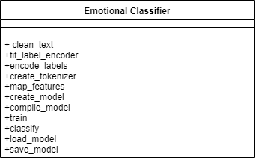

**3.1.3 Sequence Diagram**

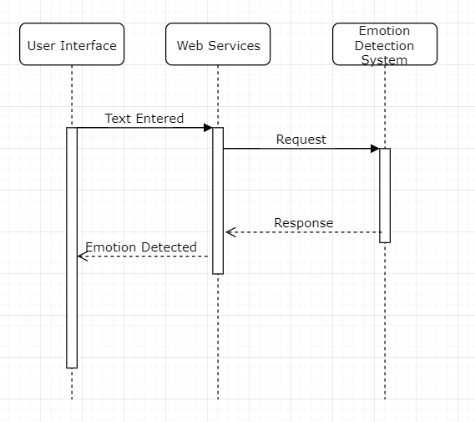

**3.2 Performance Requirements**

The system should not take more than a second to accept the input from the user. The system should be quick in response and should not take more than a second to predict the output and display it to the user.

The system is required to predict accurate results to greater extent. The system should predict emotions relevant to the text by implementing the trained hybrid model with high degree of accuracy. Since this project is state of the art project, the accuracy achieved so far is excellent. The system should be having maintainability as a feature and evolving in nature.

**3.3 Design Constraints**

**3.3.1 Usage of the Application**

The user interface of the system should be simple and easy for the user to use. As per our system, the user interface of our system is a single HTML page, where a text box is provided for the user to input the text and the output is displayed in an easy way.

**3.3.2 Response Time**

The system should not take more than a second to accept the input from the user. The system should be quick in response and should not take more than a second to predict the output and display it to the user.

**3.3.3 System Dependability**

If the request doesn’t hit the server, the user should be informed with a message. The system may be repaired. If the user enters an invalid input the system will return an error message.

**3.4 Non Functional System Requirements**

**3.5.1 Reliability**

The system should maintain itself in such a way that there are not frequent crashes and users are able to access the functionality.

**3.5.2 Availability**

The system must present high availability to the user in order to compete with the other similar software present in the market. The system should be easy to understand, use and accessible for the user.

**3.5.3 Maintainability**

The system should be easy to maintain and should not require frequent up gradations and changes. The system should be adaptable to any new changes. The system design should be easy to adapt the new changes and the system should not be designed in a way that it would be immutable. The code should be commented in order to be readable. The software system should be modified to correct faults, improve performance or other attributes or adapt to the changing needs and environment with a great ease.

**3.5.4 Portability**

The software system should perform the same on different environments. The software should be made portable to use it on various operating systems. Portability is the key issue for development cost reduction.

**4. Technical Documentation**

This section provides the information about the programming languages used, environments in which the project is developed and the dataset. It is important for all the stakeholders to get knowledge.

* 1. **Programming Languages**

1. Emotion Detection Trained Model:

Language: Python

Packages used: nltk

pandas

numpy

scikit-learn

tensorflow

keras

1. Web Services: The service calls the learning model and is developed using the flask environment of python.
2. Web UI: The web page that interacts with user is made using HTML, CSS and Bootstrap.
   1. **Tools and Environment**

We have used Pycharm tool for the backend coding with Flask framework for the web services.

The frontend has been developed in Eclipse IDE.

1. **ScreenShots**

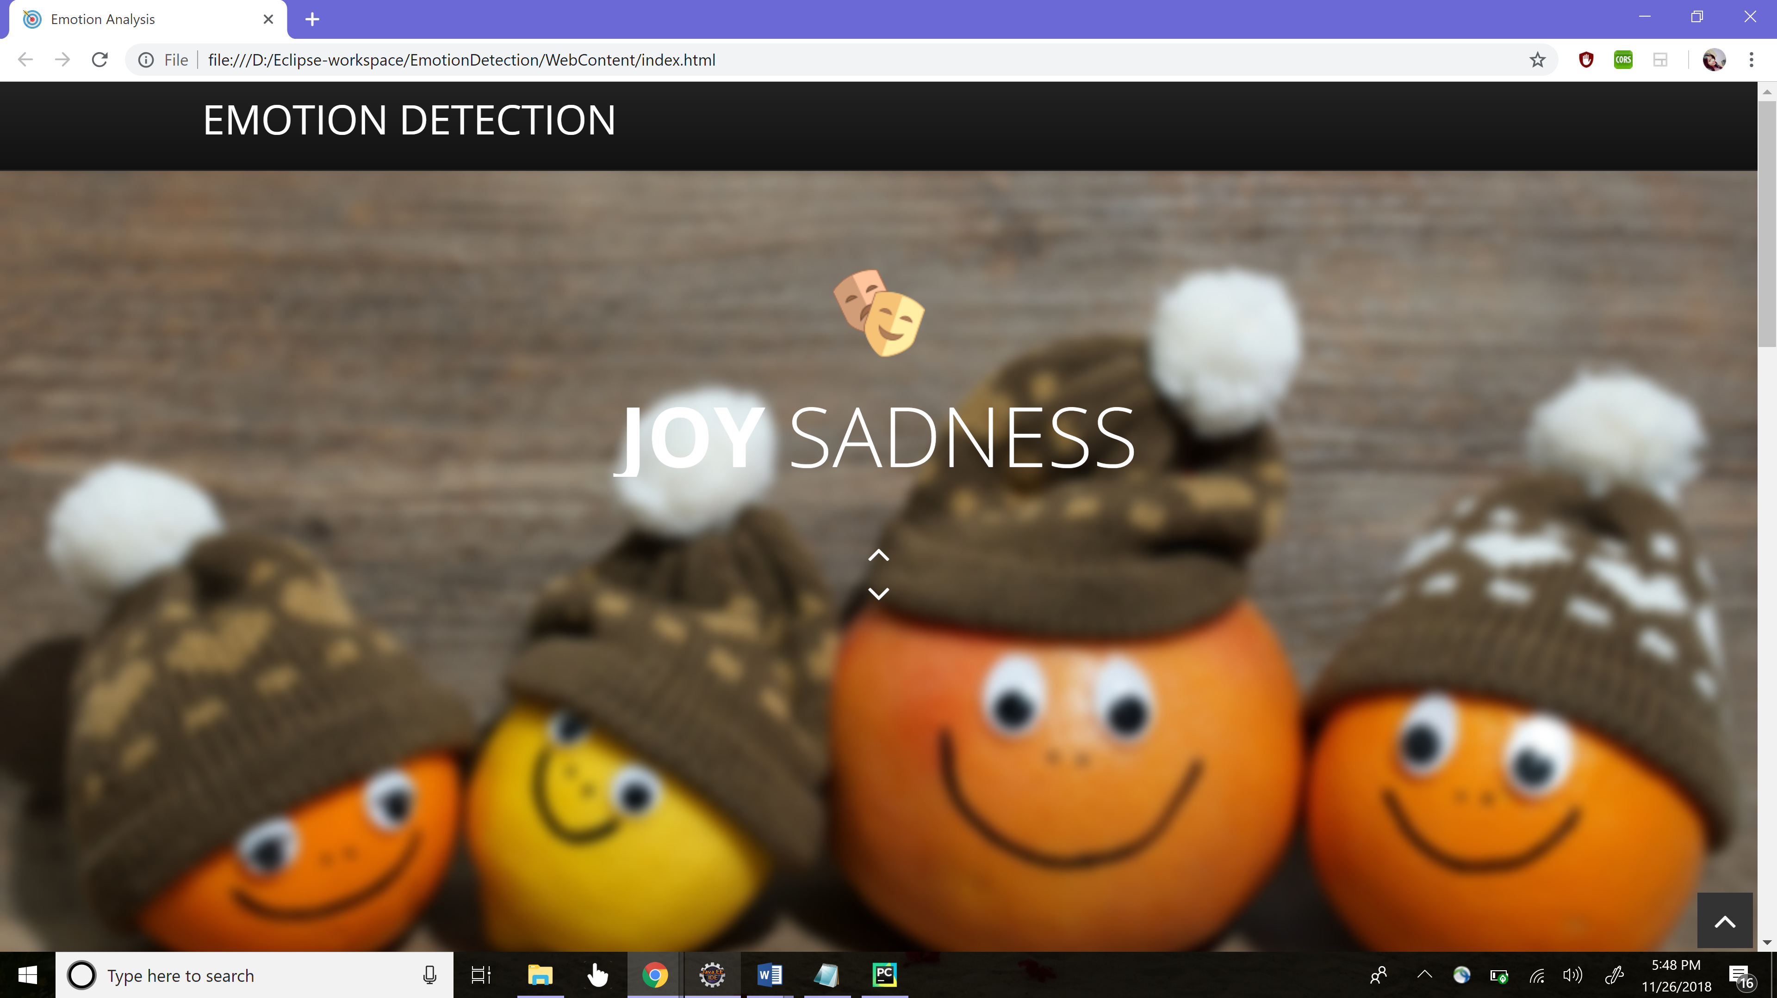

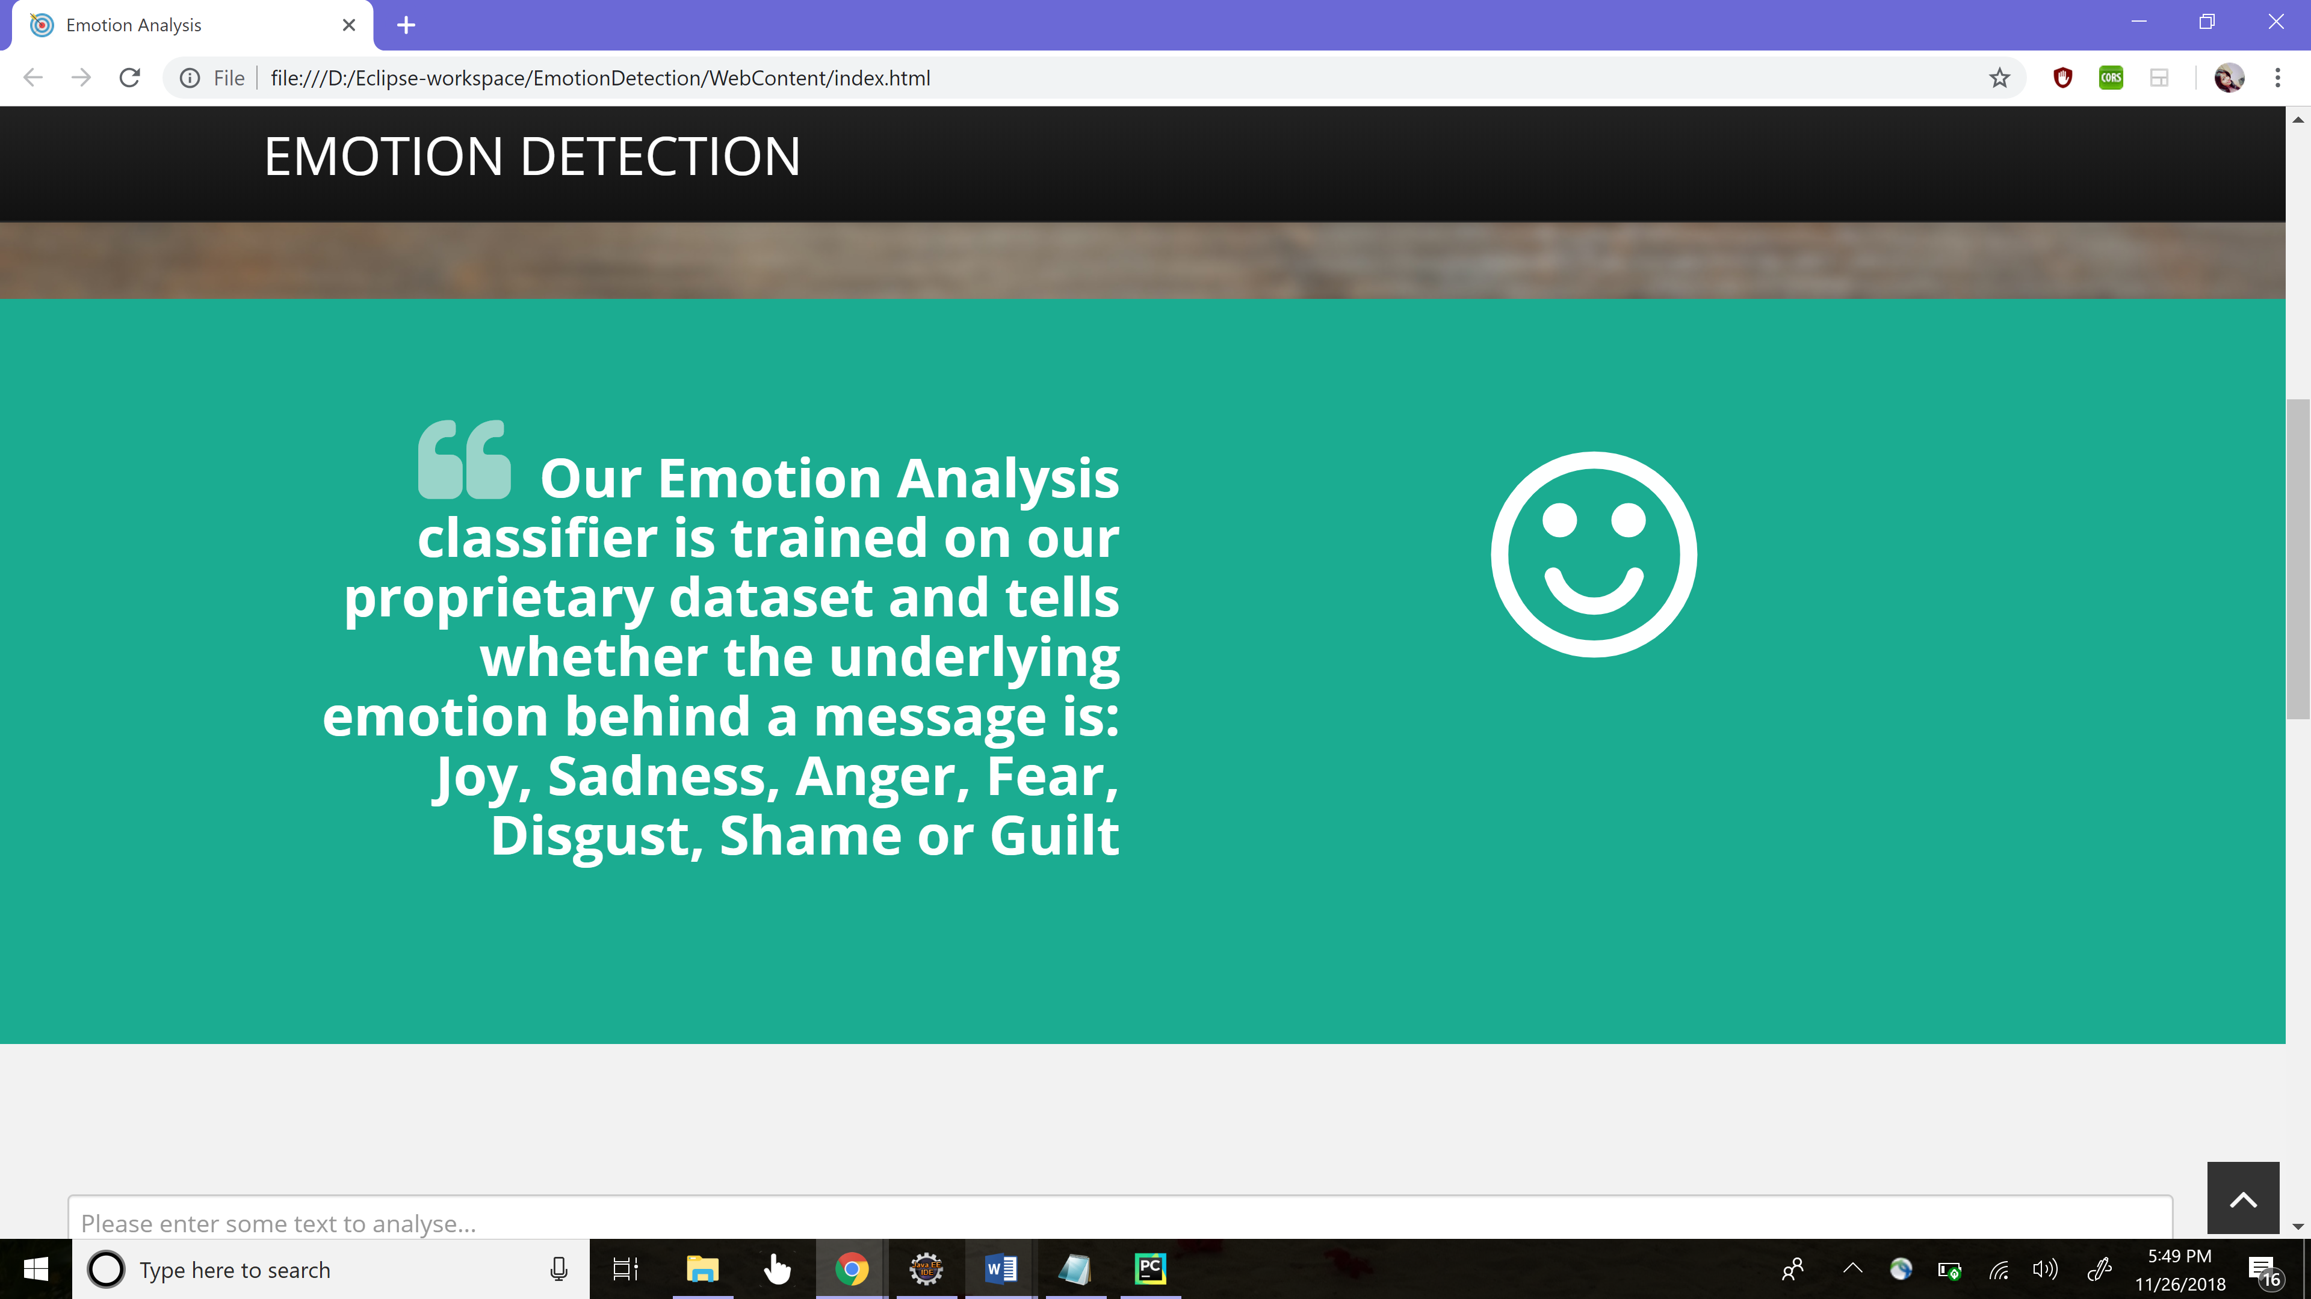

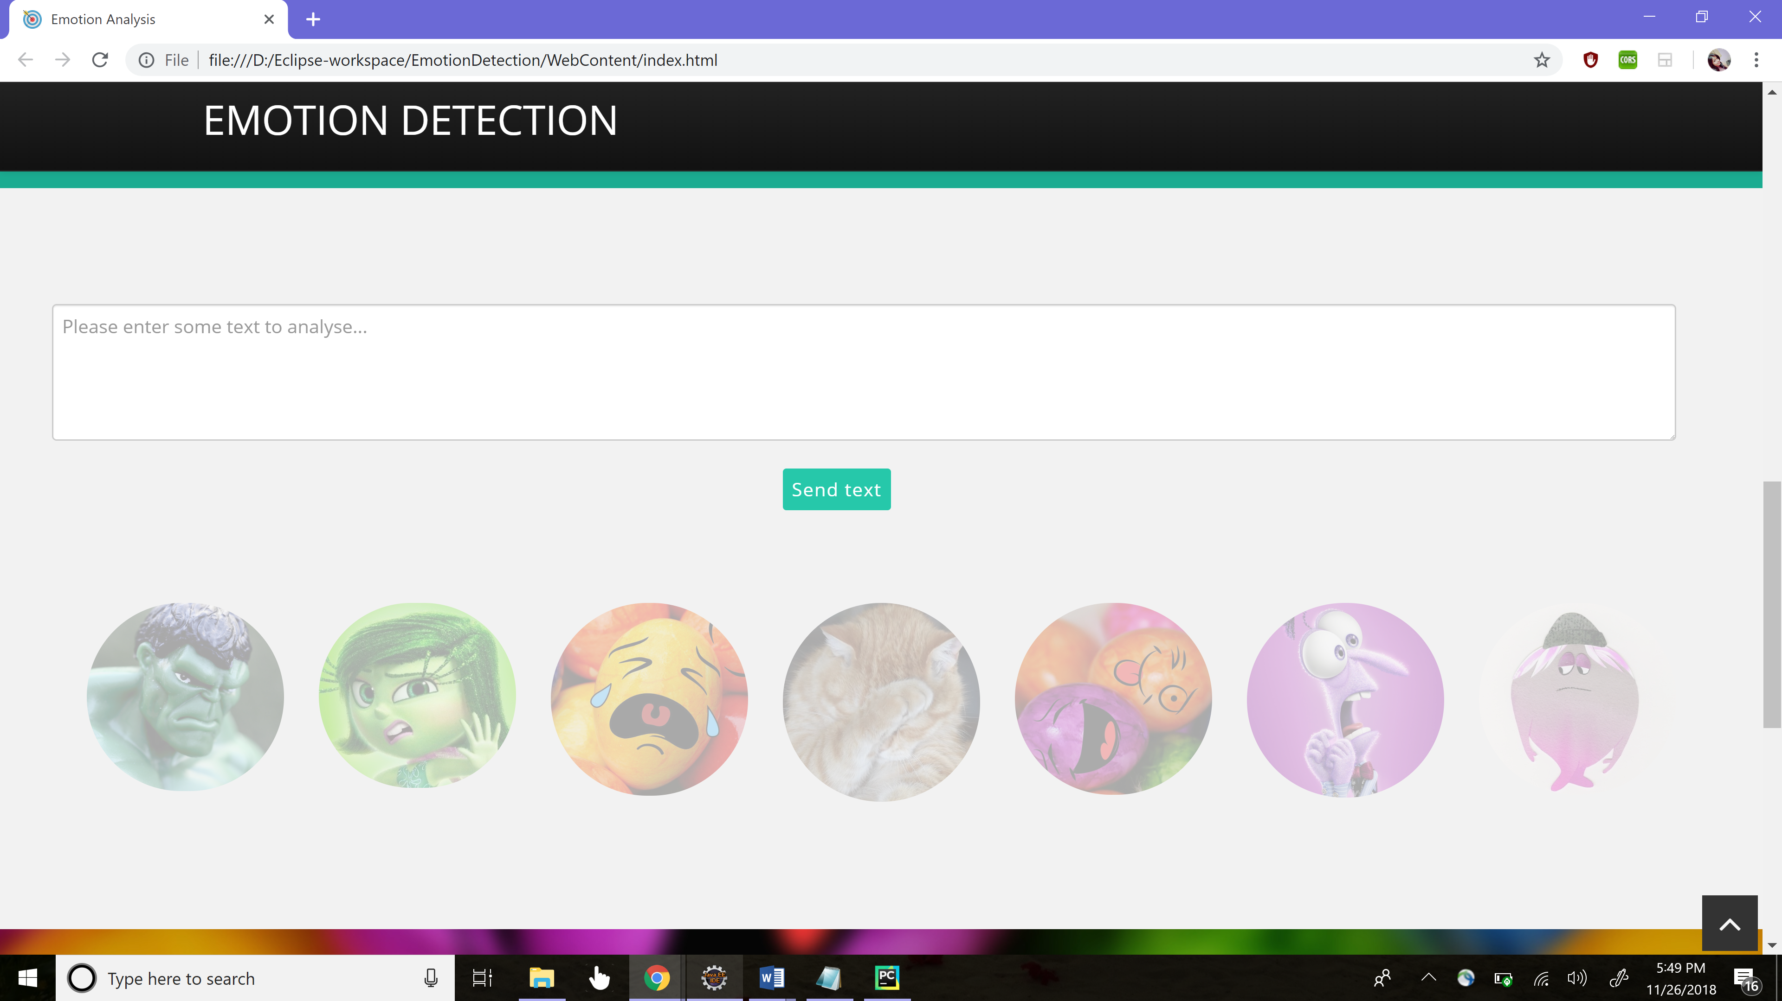

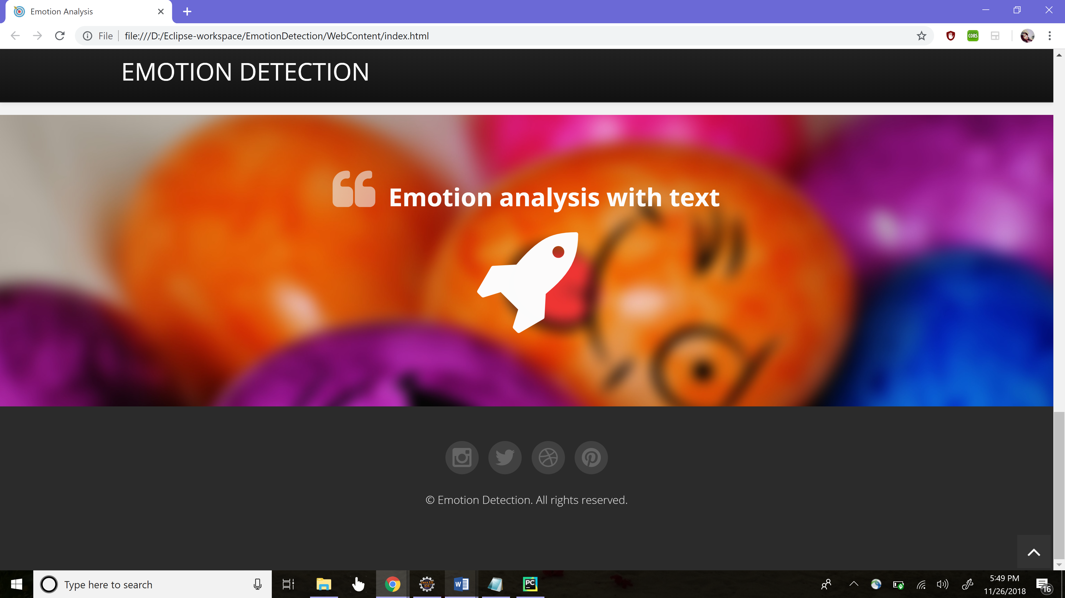

SAMPLE OUTPUT GENERATED:

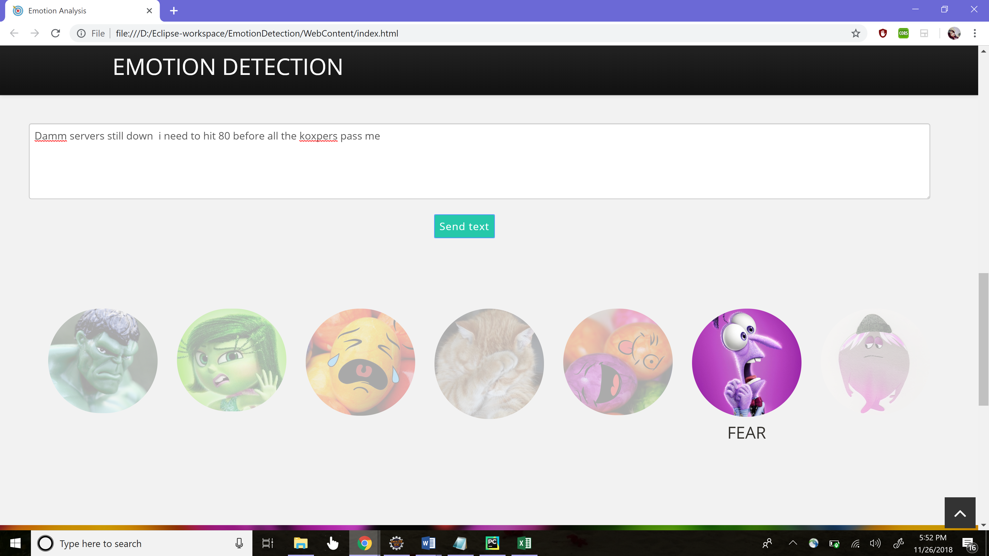

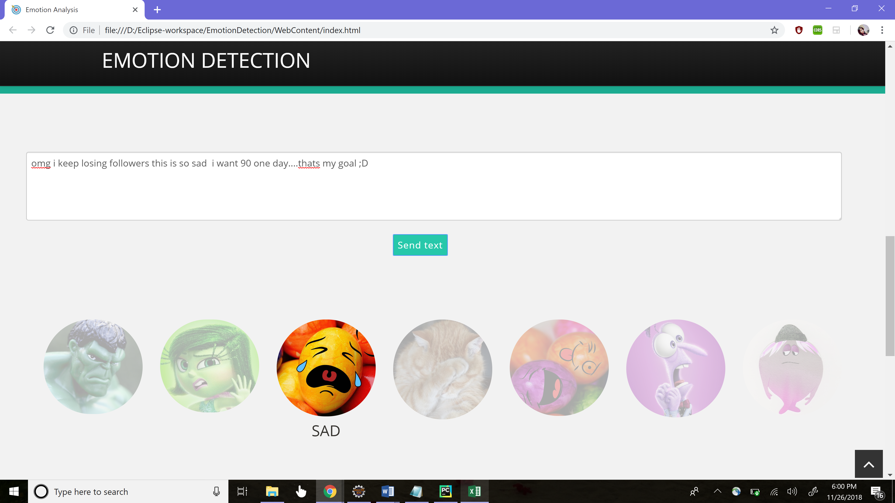

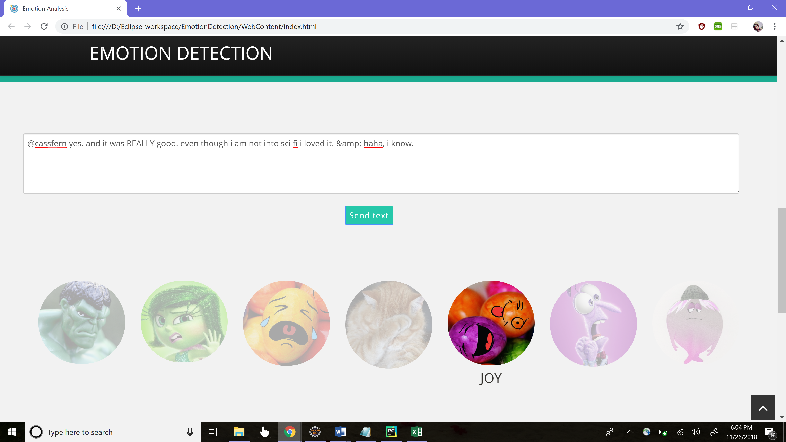

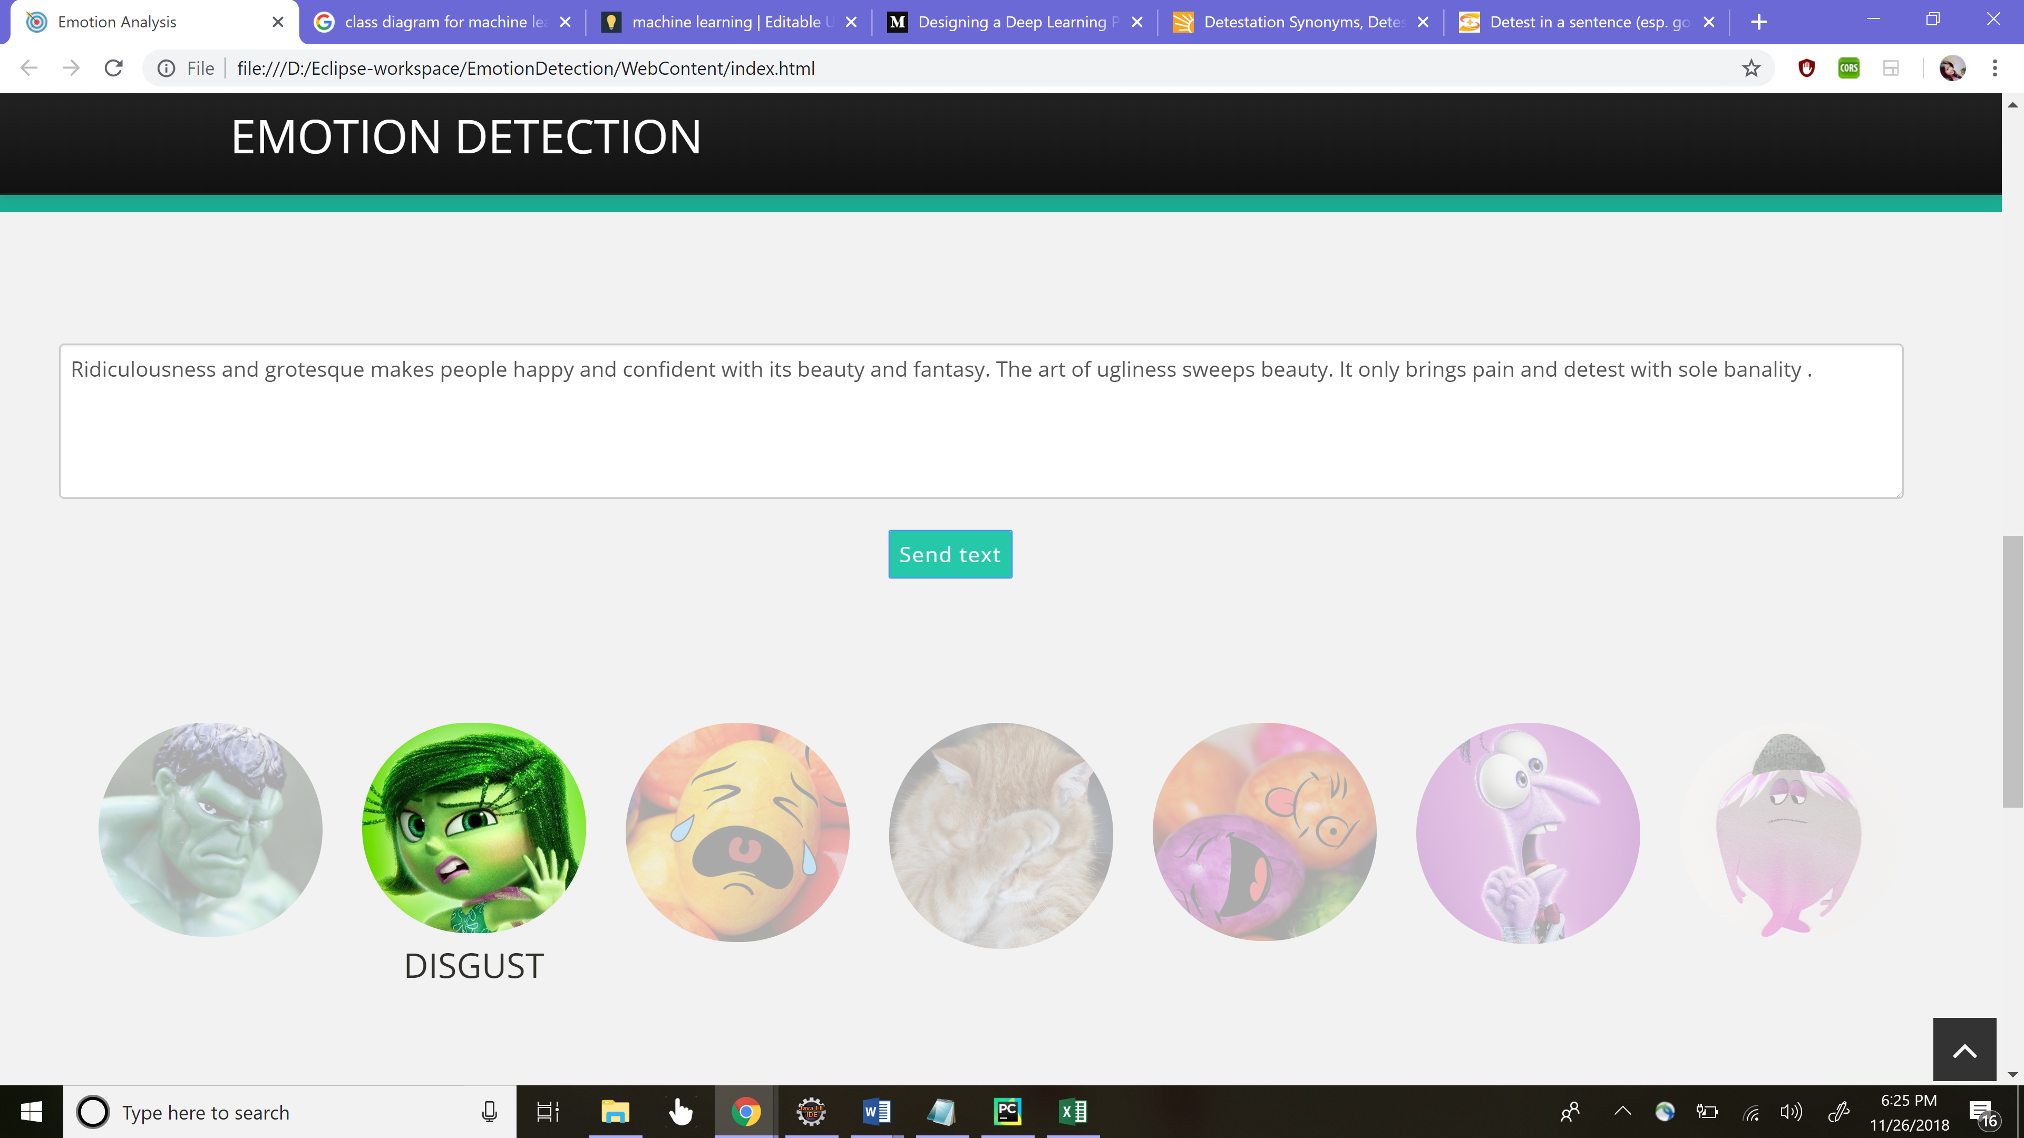

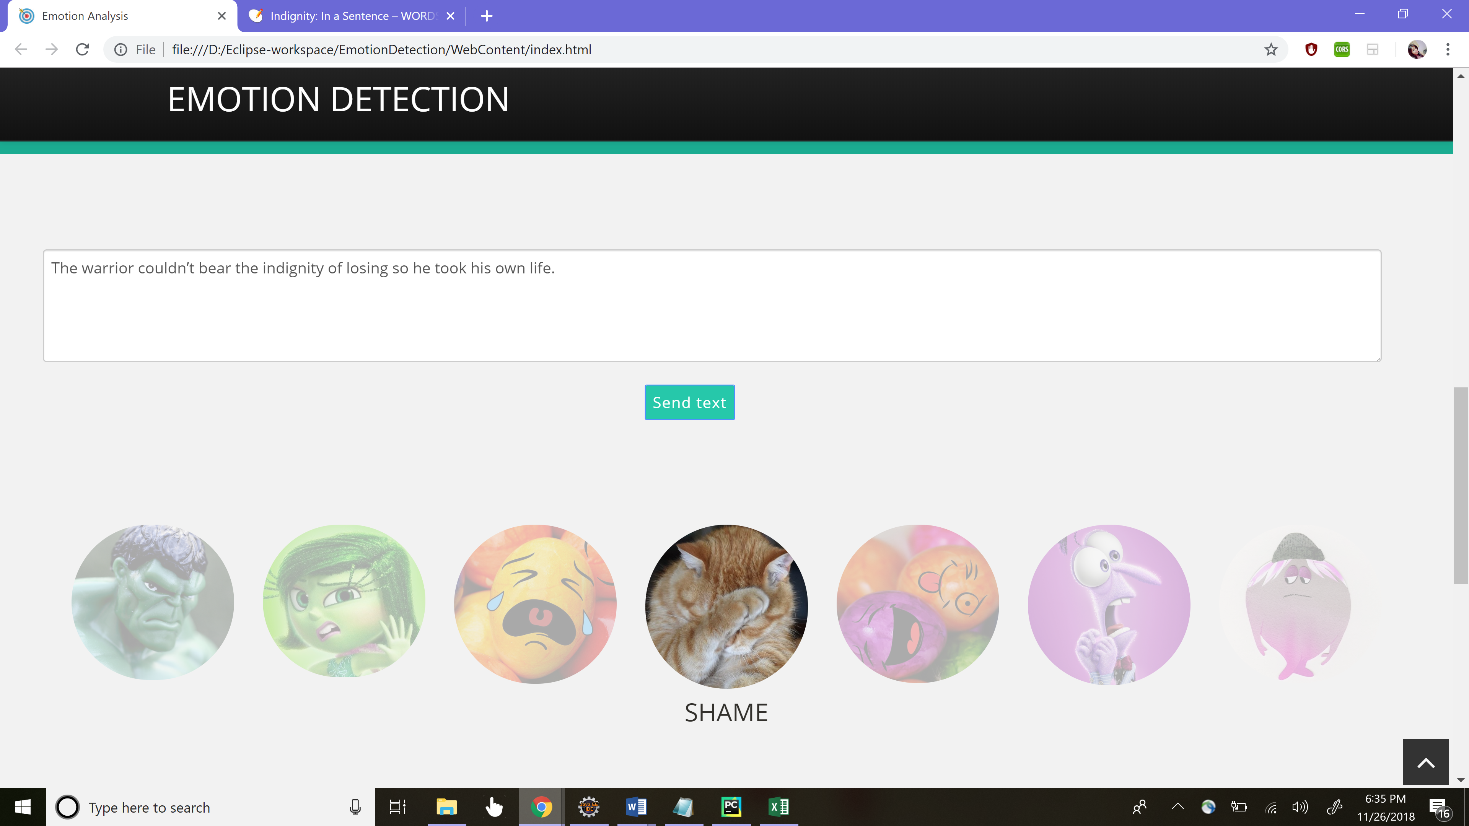

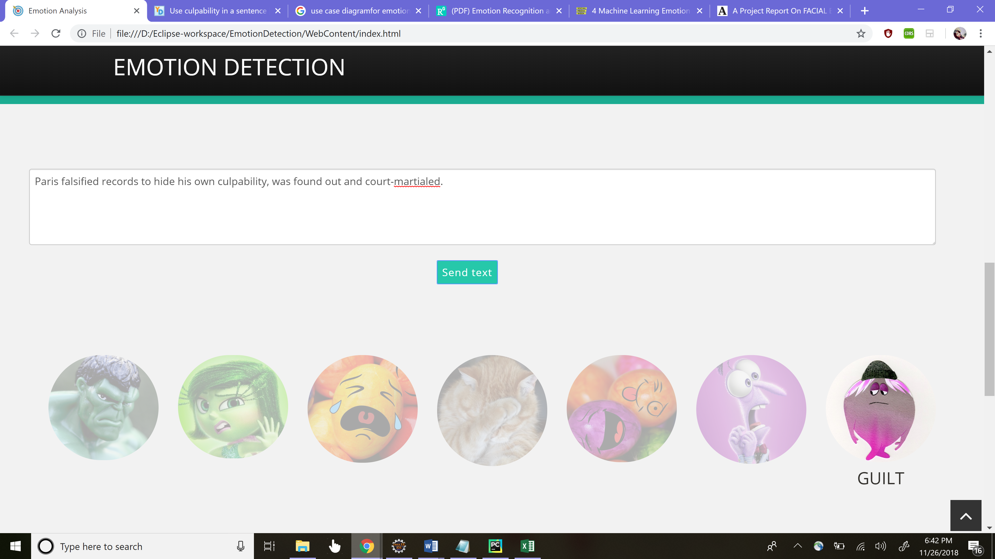

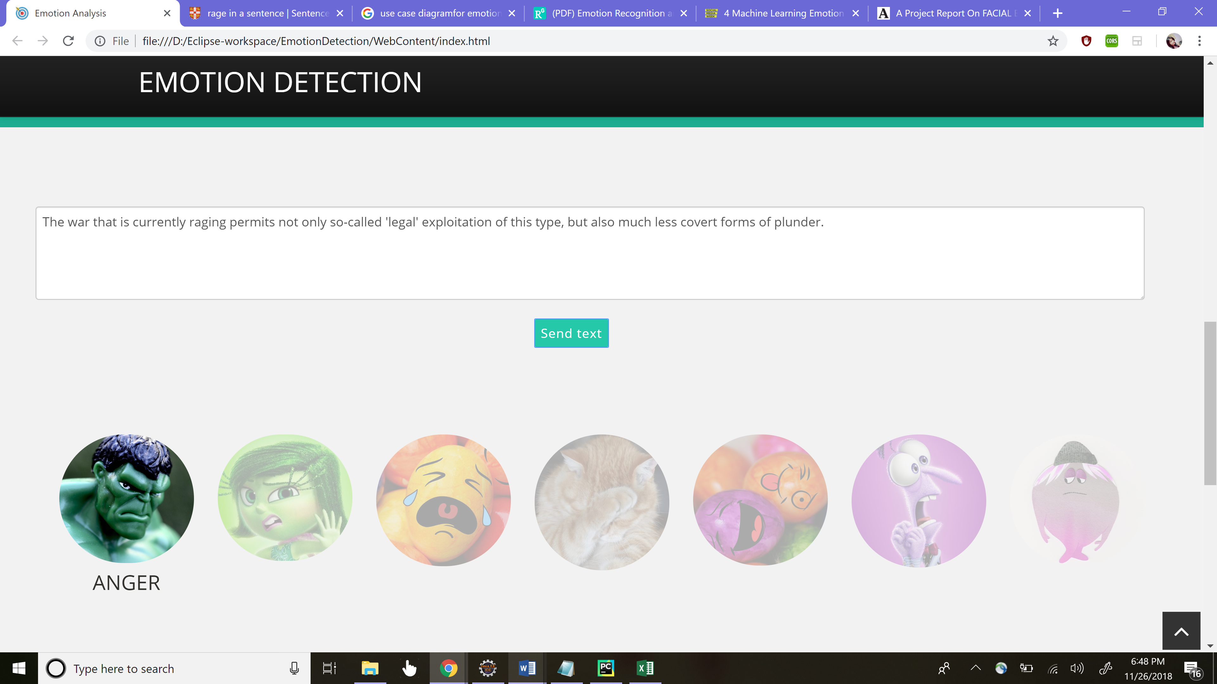

**6.RESULTS**

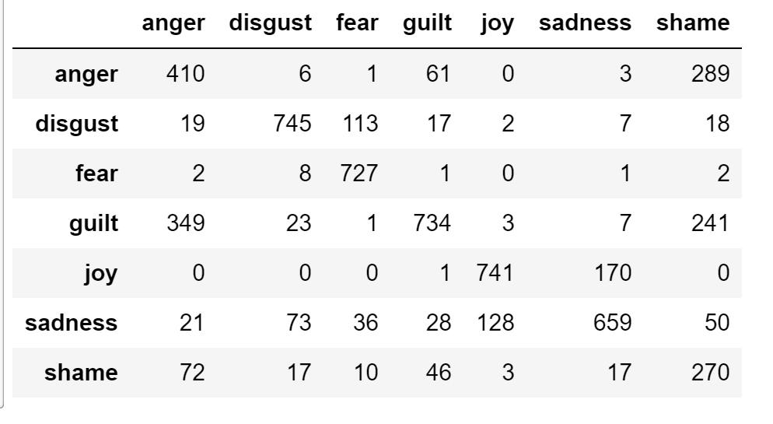

Confusion Matrix

The above confusion matrix depicts the emotion detected on the training dataset with the actual emotions as rows and predicted emotions as the columns. For ex : Our trained model predicts 410times anger correctly , 745times disgust, fear as 727times , guilt 734times, joy 741times, sadness 659times and shame 270times. The confusion matrix also states the no of times the model mistakenly predicts another emotions. The accuracy obtained is around 54% for seven classes of emotions. Microsoft achieved near about 60% for five classes of emotions.

**7.CONCLUSION**

The emotion detection system will provide the user with the emotion expressed in the text by parsing the text provided. We have taken a dataset from Kaggle <https://www.kaggle.com/c/sa-emotions>. The system can be used by any Ecommerce firm to classify the customer reviews for their products, bloggers, YouTubers etc to detect the emotion another user gives as a feedback on their content. As a part of future work, we target to include more number of emotions and try to enhance the accuracy of our model.

process (future go